A message to all members of BeLoose Graphic Workshop

Dear BeLoose member,
Are you interested in watercolor technique? We believe you should, as it is not as hard as you think. We like to offer some tips for the following rendering exercise we used in our BeLoose Graphic Workshop.
- Using H or 2H pencil and transfer lines from the image on the right into a 140 lb rough cold press watercolor paper by Winsor Newton. Transfer methods can be done by using light table or carbon paper. You can also make copy directly to the watercolor paper from the original. Make sure your copy machine can take 140 lb paper.
- Use drafting tape and tape four edges of the entire image, when you apply watercolor, you need to paint to the tape. This will allow four edges to achieve clean and straight look.
- We only use three colors from Winsor Newton "Cotman" series: Cobalt Blue, Cadmium Red and Cadmium Yellow, with # 10 round and # 3/4" flat brushes.
- Wet the sky first and wait the shin goes away and apply Cobalt Blue. Manage to leave white within if you can. Paint the road with tips we teach: Color Change, Color Glow and Color Light. Most of grey came from mixture of Cadmium Red and Cobalt Blue.
- Paint the large wall and remember to leave large white space beneath the red pot and create Graduate Value Change on the lower left corner. Apply dark vegetation against white space beneath the red pot to create high contrast so the result can be appreciated immensely.
- Render remaining walls with Cadmium Yellow with Graduate Value Change. Apply shade and shadow to appropriate areas. When done, pull the drafting tapes and you may surprise what a wonderful masterpiece you have just painted.
Please take a couple of hours and enjoy the fun journey of watercolor technique that can relax you and take the pressure off your work. We believe everyone can paint watercolor if they have tried to fail a few times with the tips. Have a good day.
Mike Lin
Brian Lin

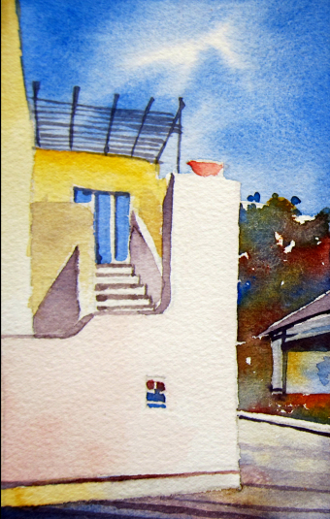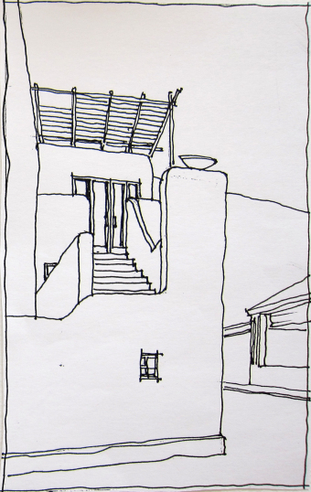
Visit BeLoose Graphic Workshop at: http://www.beloose.com/?xg_source=msg_mes_network

